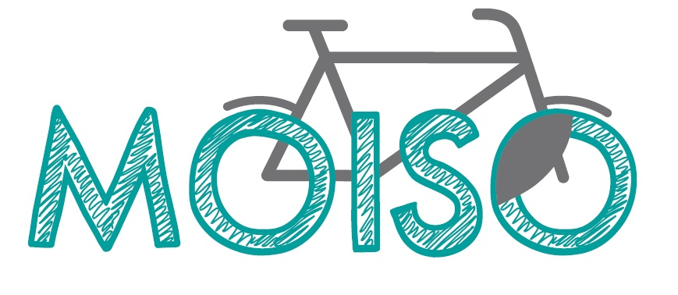

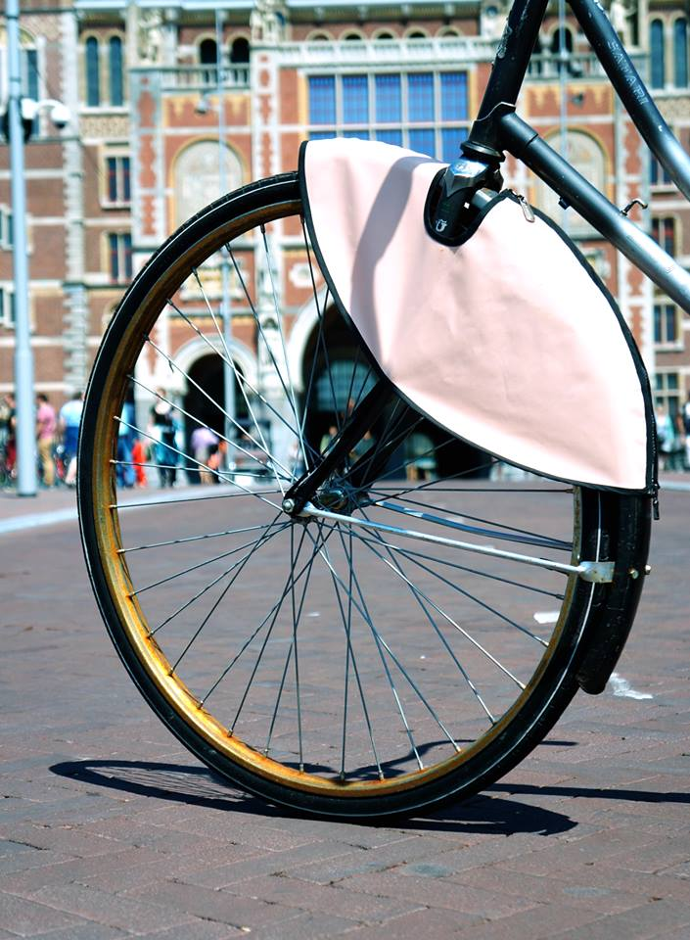

Anne De Lange

Moira Hooper

Sellina Menso

Tessa Hofte Koesveld

Amsterdam, June 14, 2013

## Executive Summary

The Netherlands is known for its biking culture and is the most biker-friendly environment around the globe. No matter which age or background, the Dutch love their bikes. They go to work and do their shopping on their bikes, they transport kids and furniture on their bikes, and all of this no matter what the weather conditions are.

One biking-related behaviour that is typically observed among young people is that they tend to put their bags over the handlebars of their bikes. The bags are seen dangling at the side of the front wheel and are often a nuisance for the biker because they get caught in between the spokes.  And although this scenario is more typical for girls with their handbags, it is potentially a problem for any biker, male or female, old or young. The dangling bag can be dangerous for the biker if it leads to an accident and the least that happens is that the bags get damaged to the dismay of its owner.

To solve this problem, Moiso has developed the bag protector. This is a simple construction that covers the part of the spokes that are a potential danger to the bag dangling from the handlebars. The Moiso bag protector is an entirely new product and our approach to solving the above-described problem is unheard of. It will be a better alternative to bike bags and crates as it does not take away space and will thus make parking your bike easier. It is also the more fashionable solution to transporting your bag.

Moiso faces a huge potential market for its bag protector. There are 881,000 bicycles in Amsterdam alone. 89.8 per cent of the Dutch population between the age of 15 and 25 has a bicycle. Moiso’s mission is to design, produce, and market a range of bag protectors. The initial target market is the Netherlands. The bag protectors will be stylish, trendy and affordable.

1. Table of Contents

1. Executive Summary 2

3. Introduction 4

a. The Problem 4

b. Our Solution 4

c. Value Proposition or Business Model 4

d. Keys to Success 5

4. Product 5

a. Features of the product 5

b. Price Points 6

5. Market and Industry Analysis 6

a. Target Market 6

Table 1. Dutch population in 2013: Age 15-25 (Centraal Bureau voor Statistiek, 2013) 7

b. Industry Analysis 8

c. Concluding Statement 9

6. Strategy 10

a. Partner/supplier/vendor agreements 10

b. Marketing and Sales Strategy 10

c. Distribution Strategy 11

d. Service Strategy 11

7. Organizational Summary 12

a. Organizational Structure 12

b. Compensation Scheme 13

8. Financial Plan 14

a. Start-up Funding Requirements 14

Table 2. Required Investment for the first 3000 bag protectors 15

b. Break-even analysis 15

Table 3. Break-even Analysis 15

Table 4. Income Statement 16

c. Projected Cash Flow (quarterly) 16

d. MBV Spread sheet (Margin, Burn, Volume) 17

9. Contingency Plan 17

10. Expansion 18

11. Bibliography 20

12. Appendices 21

Appendix 1. The Bag Protector 21

Appendix 2. Market Research Graphs 21

Appendix 3. MBV Spread sheet 23

## **Introduction**

On the following pages of our business plan the problem and its solution are explained, as well as the value proposition and the keys to success of the bag protector (3). In (4), our product features and prices are explained followed by the outcome of our market and industry analysis in (5). (6) outlines our strategy and (7) details the organizational summary. The financial plan is presented in (8) followed by the contingency plan (9) and our plans for future expansion (10).

### **The Problem**

The problem we are addressing is that of bags getting caught between the spokes of the front wheel of the bike. We, ourselves, have experienced our handbags getting caught, which has lead to us falling off our bike and/or the bag getting damaged. This is something not only women encounter but also men who, for example, carry their sporting bags to the gym or anyone who does the grocery shopping. It is also an issue for mothers whose kids sit at the front of the bike as their feet might be dangling down and are therefore at risk of getting caught in between the spokes.

### **Our Solution**

Moiso has designed a bag protector for the front wheel, which is similar to the already existing jacket protector for the back wheel of the bike. The bag protector will be attached to both sides of the front wheel and will thus cover a part of the bike’s spokes, therefore protecting whichever item is hanging from the handlebars. (Please see pictures in Appendix 1 to better visualize this.)

### **Value Proposition or Business Model**

The business model is to design, produce and market the bag protectors initially to the Dutch market, in particular to the part of the Dutch population aged between 15-25. Moiso’s aim is to create a new product with the aim of beating the existing alternatives (baskets, racks and bike bags). We want to grow Moiso aggressively and establish it as a quality brand name in the bicycle accessory market. The goal is to become the market leader in front wheel bag protectors.

Moiso plans to sell the bag protector through the following distribution channels:

* Bike retailers and shops. Selling through bike retailers requires us to incorporate a margin for the retailer into our calculations.
* Via our website [www.moiso.nl.](http://www.moiso.nl/) In this case we need to take into consideration packaging and sending costs.
* Companies that can have the bag protector customized with their logo and use it as a means of advertising by giving it away for free to potential customers.

Due to the product’s novelty it has to be our priority to create awareness for the bag protector. We believe that an important first step is to convince bike retailers of its value and of its marketability.

### **Keys to Success**

Moiso’s keys to success is firstly, the product’s design, and secondly, our marketing strategy. The Moiso bag protector is an entirely new product and our approach to solving the above-described problem is unheard of. Our emphasis will be on making it a fashionable and funky accessory that will be the latest must-have on the market for bike gadgets. Therefore, the design is of utmost importance. It needs to be of very high quality and needs to satisfy many different tastes. The marketing is the key to generating demand for the bag protectors and creating a brand for which people will gladly spend their money. Moiso has to be marketed similarly to a fashion brand where people do not simply purchase the product because they need it but because it makes their bike look cooler.



## **Product**

### **Features of the product**

The product will be made of Nylon, a thermoplastic, silky material that is very sturdy, durable and waterproof. Nylon is also available in many colours and can be printed on. The bag protector will be sewn in a way that allows you to fit it over the fender and around the so-called head tube (the bar above the fork). It will be attached to the hub on either side of the wheel with elastic bands (see Appendix 1).

The bag protector is designed to be highly durable. It is a product that will come in different designs and colours, is affordable and easily replaceable. Therefore, customers can frequently change their bike’s style (as is the custom amongst many young Dutch people). Alternatively, it is possible to keep the same bag protector for many years, as it is a high quality product.

### **Price Points**

At the time of writing, the bag protector is the sole product that Moiso will be selling. According to the outcome of our market research, the average price that people were willing to pay for the product is €14.61. We are planning to sell the most basic bag protector for €12.95 to bike retailers. Adding VAT and a margin for the retailer, the bag protector can be sold for approximately €17.90 (the exact margin that retailers want is unknown at the time of writing). As we start offering different designs on the bag protector we will charge higher prices.

## **Market and Industry Analysis**

### **Target Market**

The initial target market for our bag protector will be young women aged 15 to 25. Women in this age group are trendsetters, they are the first ones to realize a products fashion potential and therefore, they are the first ones to adopt a new product and turn it into a trend. There are of course also many followers amongst this age group that will eventually copy the trend; however, there is an overall desire to maintain ones individuality. They can do so with Moiso’s bag protector. It is a trendy accessory, entirely new to the market, and it comes in different colours and designs, which allows every user to keep an individual touch. This age group hangs their bags over their handlebars the most frequently compared to other age groups. They are familiar with the problem and need the solution.

With regard to our geographic strategy we will focus on Amsterdam and then expand to the rest of Holland before finally going international.

We researched existing data to find out how many bicycles are in the Netherlands and especially in Amsterdam. According to research conducted by the Central Bureau of Statistics in the Netherlands (2007) we see that 89.8 per cent of the Dutch population between the ages of 15 and 25 has a bicycle. Even more interesting, 91.4 per cent of women between 15-25 have a bicycle. This means that there is a huge potential market for the bag protector. A survey from the Gemeente Amsterdam (2011) shows that there are 881,000 bicycles only in Amsterdam. This implies that there is a potentially very profitable market for Moiso’s product.

We started our own market research on the 13th of March to check our assumptions about the right target group. 129 people have filled in the online survey. The survey population is not large enough to make the outcomes valuable but we can draw some first conclusions from them. According to the results, we believe that our product has a good chance of being successful. Out of 129 respondents, 58.2 per cent like the bag protector only after reading a short description of the product. The respondents have not seen the actual product, which makes us believe that an even greater number will like the bag protector once it is on the market. In addition, women like our product more compared to men, as predicted. We can also conclude that the age group from 17-25 is the best target market for the bag protector because this is the biggest group that likes the bag protector. For more results of the market research see Appendix 1.



Short facts[1]:  
 - There are 881,000 bicycles in Amsterdam  
 - 91.4% of women between 15-25 in the Dutch population have a bicycle.

- 58.2% of the population likes the bag protector .

- 65% from the women of the population like the bag protector.

- 64.3% of the population aged 17-25 like the bag protector.

- 1 in 5 people of the population would like to stay in touch, by giving their email address.

### Table 1. Dutch population in 2013: Age 15-25 (Centraal Bureau voor Statistiek, 2013)

|  |  |  |
| --- | --- | --- |
| **Dutch population, age 15-25 (2013)** | | |
| **Men** | **Women** | **Total** |
| 1,146,000 | 1,108,000 | 2,254,000 |

According to this table with statistics from the Central Bureau for Statistics (2013), combined with the results from the survey from the ‘Gemeente Amsterdam’ in 2011, which found out that 91.2 per cent of women between 15-25 have a bicycle, we can conclude that 1,010,496 women in the Netherlands between 15 and 25 have a bicycle. This means that our initial total target population has 1,010,496 persons in it. Once we add males in this age group, our target group will become 2,023,560.

Combining these numbers, which are found in existing data, with our own market research, we can draw another conclusion. 64 per cent of women between 17-25 in our market research like the bag protector. If our market research is reliable we can state that 64 per cent of 1,010,496 women like the bag protector. Consequently, approximately 646,717 women in the age group 15-25 are potential future users of the bag protector. This is 28.7 per cent or almost one third of the complete Dutch population in this age category.

### **Industry Analysis**

The competition of the bag protector is relatively high. There are three products competing with the bag protector. In Table 1 you can see the three different products, a short explanation of what they are, and what their disadvantages and advantages are. We believe that it is important to know why people might still buy the competition’s product because this enables us to realize and focus on our own competitive edge.

To have an estimate of how many racks, crates and bike bags there are in Amsterdam we investigated how many of these products we saw on bikes in Amsterdam. We went to Sloterdijk, Koningsplein and Central Station in Amsterdam. Out of 935 bikes that we counted, 530 bikes (56.7%) did not have any of these products on their bike. The most commonly used product seemed to be the rack, which was seen on 145 (15.5%) bikes, followed by the bike bag on 115 bikes (12.3%) and then the crate on 70 bikes (7.5%). We have also seen some combinations of these products on bikes, namely the bike bag with the rack on 60 bikes (6.4%) and the crate with a rack on 15 bikes (1.6%). We have not seen any bike with a combination of the crate and the bike bag. Based on these numbers our product’s biggest competitors are the rack and the bike bag. Extrapolating these numbers suggests that our potential market in Amsterdam consists of 499,527 (0.567x881,000) bikes.

Table 1. Competition Analysis

|  |  |  |  |  |
| --- | --- | --- | --- | --- |
|  | **What is it?** | **What is its problem?** | **Our solution to the problem.** | **Why x instead of the bag protector?** |
| **Rack**  **(‘Rekje’)** | It is a metal device above the front wheel of the bicycle that facilitates carrying loads. This is a very common accessory in the Dutch biking culture. | This object is not very convenient because when you park the bicycle it is usually too big for the parking spot. You cannot fit your bike between two other bikes. It is also not very attractive. | The bag protector is flat at the side of the wheel. This means that it doesn’t need any space and certainly not in a horizontal way, like the rack. So you don’t need more space than with a bike without a bag protector. | The rack can carry things. You don’t have the weight on your handlebars. You can also transport bigger items with a rack than with only the handlebars. |
| **Crate**  **(‘Krat’)** | The crate is a basket above the front wheel of the bike, which hangs over the handlebars. | Same problem as rack. | Same solution as rack. | Same problem as rack. |
| **Bike bags**  **(‘Fietstassen’)** | These are bags at the sides of the back wheel of the bicycle. You can put things in them. | They are not ‘cool’ at all but rather ugly. A lot of old people use them so young people do not really fancy them. | Our product is hip, trendy and cool. The bag protector is not ugly like the bike bags. | You can transport more with the bike bags because you have two bags in which you can put stuff. |

### **Concluding Statement**

Given our basic target market (young men and women in Amsterdam) and the industry analysis, and assuming that we sell 1000 bag protectors monthly, we perceive a market of €12,950.00 in revenue per month, from sale of our bag protector. Assuming we sell a bag protector to every cyclist who does not have a crate, basket, or bike bags in Amsterdam, we generate revenues of €6,468,874.70 (499,527x€12.95).

## **Strategy**

### **Partner/supplier/vendor agreements**

The partners with whom we will be working together are:

1. The suppliers of the materials, in particular the Nylon, zippers and elastic bands
2. The sewing workshop that will manufacture the bag protectors
3. The company that is going to print on the Nylon
4. The retailers that will sell them

We will be working with all of our partners through formal contracts.

### **Marketing and Sales Strategy**

Our three sales channels are bike retailers and shops, our website, and companies that use the bag protector as a means of advertising. During the initial stages of this start-up, we have to find a bike supplier that stocks local bike retailers and shops and who is interested in distributing our bag protectors. This is better than going to every store individually as they are usually reluctant to buy a product that has not proven to be successful yet. Alternatively, we could collaborate with an already existing brand to produce and sell our product.

Our sales strategy is supported by aggressive use of social media. The marketing strategy for Moiso has different angles. We have created several social media accounts, amongst them Twitter, Facebook and LinkedIn. We chose the name *Moiso Amsterdam* for all our social media accounts to retain continuity in our media appearance. An article from the University of Zurich (Cvijikj et al., 2011), states that the best time to post things on Facebook is on Wednesdays, Tuesdays and Fridays from 8-16.30h or after 19.00h in the evening. We will use this information as a guideline in our social media.

Next to social media we will also be sending newsletters every three weeks with new findings about biking and news from Moiso. This newsletter will be sent to the people in our database, which consists of the people who stated in the survey that they would like to keep in touch with Moiso. We are also putting up a link on our website and social media where you can sign up for our newsletter.

In addition, we are planning to do different actions to raise the attention of our target group. For example, by doing a QR-code guerrilla action. We will make a QR-code of our website, print this code a hundred times without any text and spread it at the university libraries and other places where we can find our target group.

Moiso also needs media attention to get to a broader audience. We are already in touch with the manager of *7 ditches tv* about an online video interview, which will be posted on www.sprout.nl, www.nuzakelijk.nl and www.7ditches.tv. To attract more media we are going to write some press releases and send it to magazines, platforms and websites that are also targeting our target group.

Last but not least, we are making a short clip about our product and we will use it to raise awareness for our brand and to get more attention from the media.

### **Distribution Strategy**

We are going to distribute the bag protector via several channels. To begin with, we want to sell the bag protectors primarily through local bike shops in Amsterdam who in turn will then sell it to the actual consumer. This enables us to use the bike shops as retailers. We can also start selling the bag protector through our website. However, this will only pick up once our product becomes known. Our website is connected to PayPal and can thus be used as a web shop.

Another possibility for the distribution of the bag protector is via big and small companies that want to use the bag protector as a means of promotion and advertising. This strategy implies that the company pays for the bag protector with their company name, logo or ad on them.

### **Service Strategy**

Anybody buying a bag protector will receive a business card with it that contains our contact and website details. They can then check out Moiso online and sign up for the newsletter and/or give us feedback on their bag protector. If consumers buy the bag protector via the web shop they will be asked for their email address. Two months after their purchase we will send them an email to ask if they are happy with their bag protector and if they have any suggestions for improvement. We will also ask if they would like to have another design or colour. A link in the email will enable them to easily go to the web shop and buy another print. We will therefore not only find out what needs to be improved but we are also making our customers aware of the other designs, which could possibly make them returning customers.

## **Organizational Summary**

### Organizational Structure

The founders of Moiso are four women with different majors and with knowledge of different subjects. The tasks and responsibilities are divided amongst the four team members. They are responsible for the tasks that their function represents.

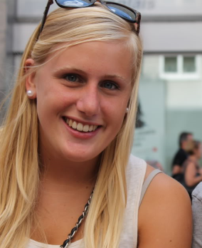**Anne de Lange (20)**

**Function**: CEO

Anne came up with the idea of the bag protector. She studies Communication Science and is experienced in organising events and leading teams.

**Responsibility:** Anne is responsible for assuring that everyone knows what their tasks are and that the team works together in a harmonious way while maintaining its respectful but driven attitude. She arranges the meetings, makes sure everything runs smoothly and that deadlines are met. If conflicts arise the CEO has to find a diplomatic way to solve them and to facilitate future processes.

**Moira Hooper (21)**

**Function**: CFO

Moira studied Economics and Business at the University of Amsterdam. Her exposure to financial and economic topics during her studies has given her a broad understanding of finance-related issues and a more analytic view of the business.

**Responsibility:** Moira is responsible for Moiso’s finances. It is her task to determine the budget, to keep an overview of the costs, to set up the financial plans, and to detail how Moiso plans to make a profit. She does the financial administration of expenses and incomes. She is also responsible for the administrative organisation of the company.

**Sellina Menso (22)**

**Function**: COO

Sellina has a broad background in sociology and business studies. She has a sharp view on organizational processes. She worked for the central student board where she developed organizational and management skills.

**Responsibility:** Sellina is responsible for the operations of the company. Her tasks include getting the materials, and finding and working together with producers and suppliers. She is responsible for the production process of the bag protectors.

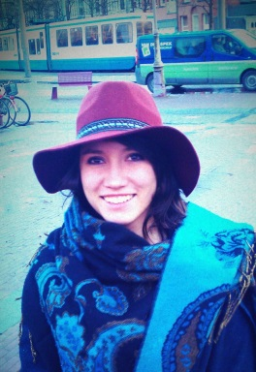**Tessa Hofte Koesveld (20)**

**Function**: CMO

As a result of her knowledge and experience in marketing, Tessa was chosen to be Moiso’s CMO. She studies Communication Science and works for a PR-agency.

**Responsibility:** Tessa is in charge of all marketing and PR-related tasks at Moiso. She is responsible for Moiso’s publicity and her tasks involve managing the online and offline media. She is also responsible for the market research and outcome analysis. Furthermore, she is Moiso’s contact person for the press.

### Compensation Scheme

No salaries will initially be paid. As Moiso grows and becomes increasingly sustainable, the team will come together to discuss possible changes in the compensation scheme.

* 1. Coordination and Decision-making Rules & Policies

Every team member has her own function in the company and knows what her responsibilities are. The team meets on a weekly basis to discuss past achievements and failures and future steps and challenges. The purpose of the meetings is also to facilitate the decision-making process and to allow the team members to agree on present issues. All decisions will be discussed and agreed upon by the whole team.

* 1. Statement Regarding Company Ownership

Moiso will be established as a Dutch company, which will be owned equally by its four founding members, subject to the co-founders equally contributing to the initial funding (start-up capital) of the company. To the extent that external financing is secured, the interest of the founding partners will be reduced on a pro-rata basis.

If one of the co-founders decides to terminate her involvement in Moiso she can sell her share of the company. First, the other team members will have the chance to make a bid on the share. If no team member wants to buy the share it can be sold to someone outside the company.

## **Financial Plan**

The following section of the business plan is divided into four parts. We start by describing the Start-up funding requirements (a.) followed by the breakeven analysis (b.). Next, we present the projected cash flows (c.) and finally, the MBV Spread sheet (d.).

### **Start-up Funding Requirements**

Moiso has initial funding requirements to cover the costs of securing product patent, production of the first batches and marketing. A very important component of Moiso’s start-up cost is the patent because our product is newly invented and needs to be protected against others wanting to imitate it. The costs for getting a patent include the application fee, the patent attorney and the ‘research of the state of the art’[2]. The largest part of the start-up costs consists of the production of the bag protectors, which includes materials and labour costs. The third key component is aggressive marketing to raise awareness for the new product. Total start-up costs are estimated at 24,500 Euros.

### Table 2. Required Investment for the first 3000 bag protectors

|  |  |
| --- | --- |
| Patent (incl. patent attorney) | €8,000 |
| Production (materials and labour) | €14,000 |
| Marketing | €2,500 |
| **Total Start-Up Funding Requirements** | **€24,500** |

### **Break-even analysis**

The break-even analysis shows that at a total sales volume of 3,000 bag protectors Moiso breaks even at 355 bag protectors sold at a price of 4.82 Euros. In this analysis we assume a sales price to be equal to 12.95 Euros, which is the price for which we are planning to sell our most basic bag protector. This leaves us with a net profit of 24,381 Euros. The variable costs consist of the different parts that make up the bag protector (the nylon, the zipper, the thread and the elastic bands) and the labour costs. The fixed costs consist mainly of the marketing activities.

### Table 3. Break-even Analysis

|  |  |  |  |
| --- | --- | --- | --- |
| **Sales** |  |  |  |
|  | Retail price per unit | €16.84 |  |
|  | Margin for Retailer (30%) | €3.89 |  |
|  | Sales price per unit | €12.95 |  |
|  | Sales volume (units) | 3000 |  |
|  | **Total Sales** |  | **€38,850.00** |
|  |  |  |  |
| **Variable Costs** |  |  |  |
|  | Materials | €2.00 |  |
|  | Labour | €2.00 |  |
|  | Variable costs per unit | €4.00 |  |
|  | **Total Variable Costs** |  | **€12,000.00** |
|  | Unit Contribution Margin | €8.95 |  |
|  | **Gross Margin** |  | **€26,850.00** |
|  |  |  |  |
| **Fixed Costs** |  |  |  |
|  | Marketing | €2,459.17 |  |
|  | Website | €9.50 |  |
|  | **Total Fixed Costs** |  | **€2,468.67** |
|  | **Total Costs** |  | **€14,468.67** |
|  | **Net Profit (Loss)** |  | **€24,381.33** |
|  |  |  |  |
|  | **Break-Even Sales Volume** |  | **275.83** |
|  | **Break-Even Price, all units sold** |  | **€4.82** |

### Table 4. Income Statement

|  |  |  |
| --- | --- | --- |
|  | **Per unit** | **3000 units** |
| Revenue | €12.95 | €38,850.00 |
| Cost of Sales | €4.00 | €12,000.00 |
| Fixed Costs | €0.82 | €2,460.00 |
| Profit | €8.13 | €24,390.00 |

After a successful launch of this first type of the bag protector, Moiso will be offering other designs that will be priced higher and will therefore generate greater net profits and consequently lower break-even sales volumes.

### **Projected Cash Flow (quarterly)**

The table below details the projected cash flows up to the second quarter of 2015. The first row exhibits estimates of the number of bag protectors that will be sold each quarter. Given the size of our market, we estimate to be selling approximately 5500 bag protectors by the second quarter of 2015.

Net income is calculated by subtracting total costs from revenues given the number of items sold. The increase in accounts payable includes all the variable costs (such as labour and materials) and the increase in accounts receivable are our revenues from selling the bag protectors to bike retailers.

Since we outsource the production of the bag protectors there is no need for any investing activities.

The majority of Moiso’s financing activities come from owner’s investment. The other part that makes up financing activities is lending.

Table 5. Projected Cash Flows

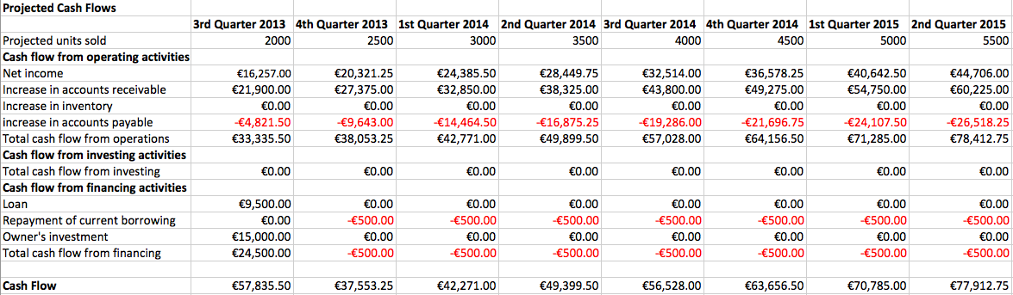

### **MBV Spread sheet (Margin, Burn, Volume)**

The MBV Spread sheet (Appendix 3) is a tool designed to enable you to ‘play’ with your numbers. Module A allows you to calculate your break-even quantities given the price that is charged, the variable costs and the burn rate. In our scenario, given a price of €12.95 and the burn rate that is detailed in Module B, we break even at a sales volume of 971 bag protectors per month. Module C is a sensitivity analysis tool, which allows you to see what happens to your pricing, burn rate, and unit costs if you sell less than the break-even volume. The analysis shows, for example, that the less bag protectors we sell, the higher a price we would have to charge in order to break even, given the monthly burn rate and variable costs. Similarly for the burn rate, the higher the burn rate the more bag protectors we have to sell, or alternatively, the fewer bag protectors we sell, the lower our burn rate must be. It is clear from this analysis that, in order to be a sustainable company, we have to focus on raising awareness and creating demand for the bag protector. Only then will we sell enough bag protectors to allow for fixed costs that include salaries and facilities.

## **Contingency Plan**

There are two major changes in the external environment that may arise in the future and prevent our start-up form being profitable. The first major change is that there is not sufficient demand for our product because people are unaware of it and bike shops are too sceptical to buy a product that has not proven to be successful. The second change is that the distributor or the bike shops want too big a share of the sales price. In this case we could lose our profit margin and would have to find another way to sell our product. A possible solution to this is to make a fair contract with the other party that is to both party’s advantage.

## **Expansion**

There are many opportunities for Moiso in the future. The first geographic target market for direct marketing is Amsterdam because it is the city in the Netherlands with the most bikes. As a next step we will expand to Utrecht, The Hague, Groningen and other student cities. We believe that our target group is found most easily in these places. As our start-up grows and becomes more sustainable, we plan to expand to the neighbouring countries. The best way to do this is get in contact with big rental companies in other countries or big brands who are interested in our product and would like to print their logo on a bag protector as a freebee for their consumers. The three biggest bicycles countries after the Netherlands are Denmark, Germany and Sweden[3].

We believe we need to keep focusing on our main target group with the bag protector. However, we not only plan to expand geographically, we also plan to introduce new product lines. Not only can we differentiate the existing product, we can create new lines of products and have multiple target groups, for example, parents with young children or the elderly. We can also develop a little bag protector for kids. It is not often the case that they put their bags over the handlebars but it is known that kids want to be and look ‘just like mummy’. We could also make matching saddle covers in the same pattern as your bag protector so you don’t get wet after the rain. We can create stickers to ‘pimp your bike’ or your jacket protector. We can make matching hockey clips (the clip in which you put your hockey stick when your biking). Once there is enough money in the company we can make a website where you can ‘design your own bag protector’, so you can draw something yourself or upload a photo.

Once we reach a certain size we will adjust our business model. Our current business model is made for a small company, not a multinational. We have to think big once we start growing. As the company grows, the business plan changes. However, the Moiso team believes that it is important to try to keep it simple and always remember where you came from.

## **Bibliography**

Centraal bureau voor statistiek (2007). Mobiliteit: voertuigenbezit naar achtergrondkenmerken 1985-2007. <http://statline.cbs.nl/StatWeb/publication/?VW=T&DM=SLNL&PA=37856&D1=0-3,5&D2=a&D3=1-10,23-35&D4=l&HD=090915-2117&HDR=G3,T,G1&STB=G2>

Centraal bureau voor statistiek (2013). Bevolkingspiramide: Leeftijdsopbouw Nederland 2013. <http://www.cbs.nl/nl-NL/menu/themas/bevolking/cijfers/extra/piramide-fx.htm>

Cvijikj, I.P., Spiegler, E.D. & Michahelles, F. (2011). The Effect of Post Type, Category and Posting Day on User Interaction Level on Facebook. IEEE Third International Conference on Privacy, Security, Risk and Trust and 2011 IEEE Third International Conference on Social Computing. Pp 810-813. Los Alamitos, CA:CPS.

Gemeente Amsterdam (2011). Enquete Fietsen in Amsterdam. <http://www.os.amsterdam.nl/pdf/2011_fietseninamsterdam_enquete.pdf>

## **12. Appendices**

### Appendix 1. The Bag Protector

 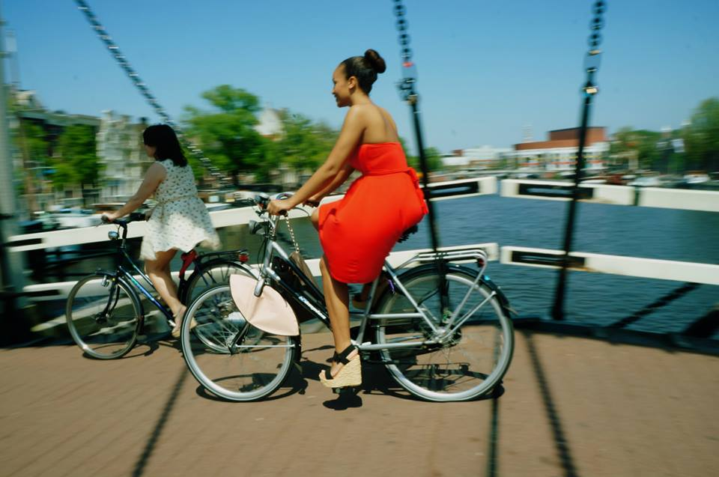

### Appendix 2. Market Research Graphs

Figure 1. Partition Dutch Population

Figure 2. Liking the Moiso bag protector: divided by age.

Figure 3. Liking the Moiso bag protector: divided by age.

Figure 4. If you see the bag protector in a shop, would you buy it?[4]

### Appendix 3. MBV Spread sheet

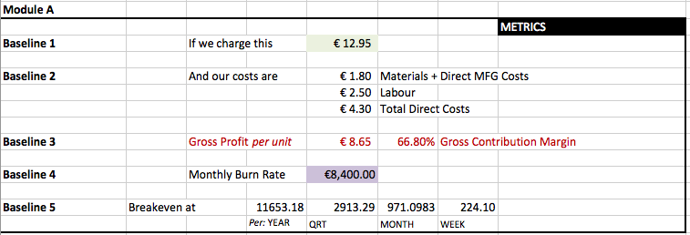

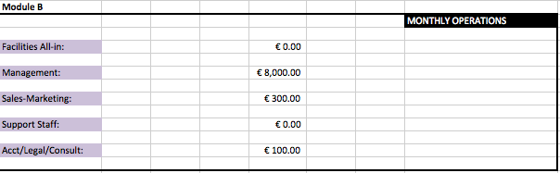

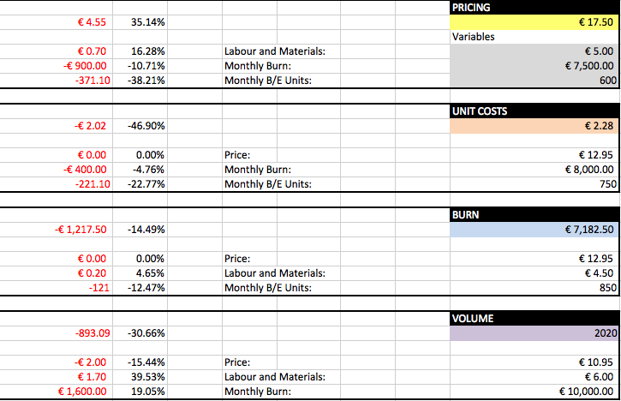

1. We define ‘the population’ (without any further explanation) as the persons who filled in the survey. It is the survey population.
2. http://www.agentschapnl.nl/onderwerp/kosten-octrooiaanvraag-nederland
3. http://top10hell.com/top-10-countries-with-most-bicycles-per-capita/
4. NB. This outcome needs some attention. 57% of the women of the survey say that they would buy the product in a shop, but they haven’t seen the product yet, only a rough sketch. We cannot tell that they are really willing to buy the product, but if we believe them, then this outcome is encouraging.